We value our volunteers; we simply couldn’t operate without them.
We offer volunteering roles that are flexible to suit different volunteers’ needs and interests. All volunteers receive training and support to help them carry out their duties. There are openings for volunteers in a surprisingly wide variety of roles as detailed in this leaflet.

Personal details:
Name:

Address:

Telephone (Home):
Mobile:
Email:
Car registration number (if applicable):
Date of Birth for Insurance purposes:

Who would you like us to contact in case of an emergency?
Name_________________________________________________________
Telephone contact details___________________________________________

If you have a disability or have any specific requirements please indicate below:
________________________________________________________________________
________________________________________________________________________
________________________________________________________________________
________________________________________________________________________

References:
Please give names and addresses of two referees, making sure they are not personal friends or family members (suitable referees include former employers, teachers, clergy or independent people who can give a view as to your experience or character).
Name of First Referee
Relationship to Applicant

Referee Address

Referee Telephone
Referee Email

Name of Second Referee
Relationship to Applicant

Referee Address

Referee Telephone
Referee Email

If known, please specify which area of volunteering you are interested in:

A sample of volunteering opportunities are listed on the following page, but please feel free to contact Gill Thorpe call 01483 547885 or email gill@guildford-cathedral.org for a full list.
Caring for our visitors:
Welcomers
Cathedral Shop Assistants
Children’s Workshop Helpers
Fairtrade Stall Assistants
Hospitality Team
Caring behind the scenes:
Holy Dusters
Maintenance Team
Flower Arrangers
Gardeners
Caring for our Services and Events:
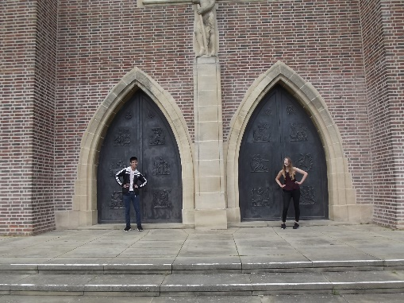
Servers
Stewards
Sunday Morning Coffee Team
Bellringers
Readers
Sunday School Helpers
Bunch of Believers Youth Group
Caring for our Heritage
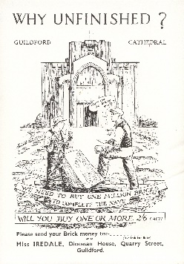
Archivist
Oral History Interviewers
Embroiderers

Additional Information:
Are you eligible to volunteer in the UK YES NO

Have you any convictions (other than spent convictions under the Rehabilitation of Offenders Act 1974?) YES NO

Declaration:
I declare that the information given in this form is complete and accurate. I understand that any false or deliberate omissions will disqualify me from volunteering.
I agree that Guildford Cathedral may hold and use this information about me contained on this application, including any information which falls within the definition of sensitive personal data under the terms of the Data Protection Act 1998, for the purposes of processing this application.
If, on this occasion, no offer is made, I agree that Guildford Cathedral may keep a record of my application for 6 months.

Signature: Date:

Please return the completed form to: Gill Thorpe, Volunteer Coordinator,
Guildford Cathedral, Stag Hill, Guildford GU2 7UP or email gill@guildford-cathedral.org
If you would like more information please call Gill on 01483 547860

