Questionnaire

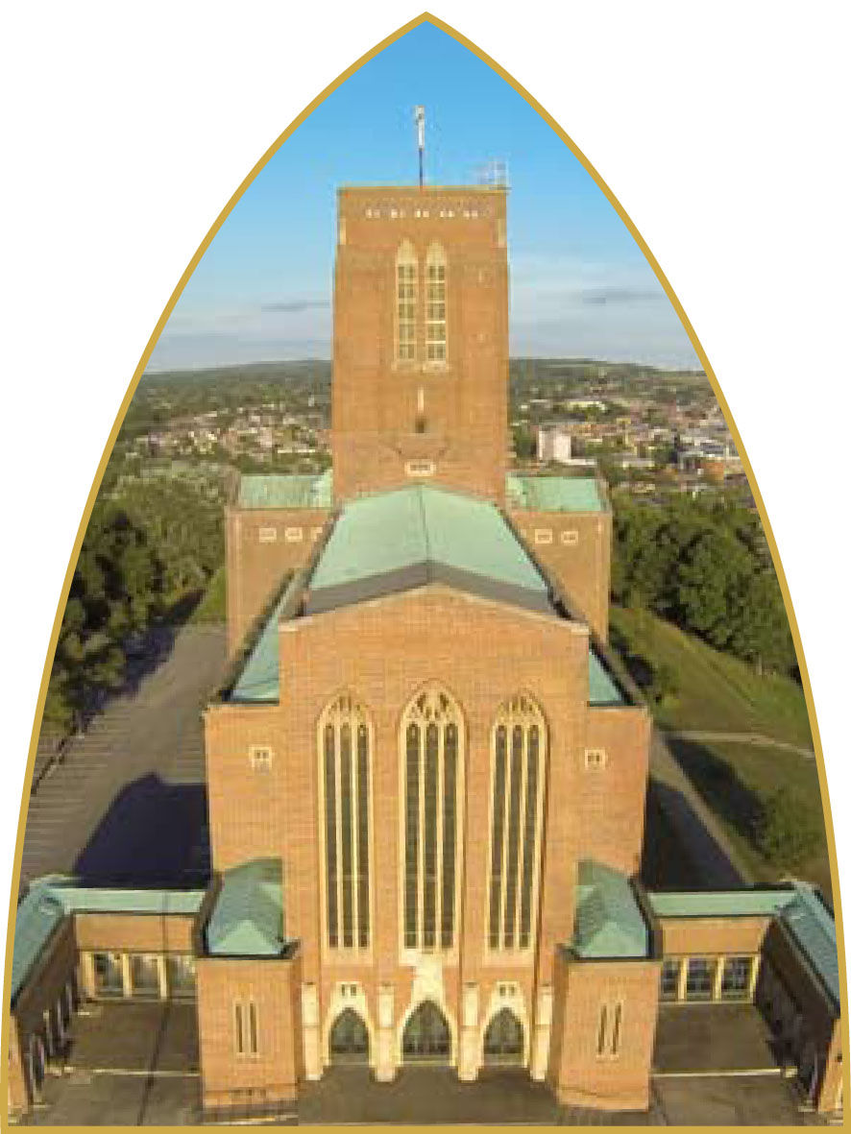

QUESTIONNAIRE

At the beginning of a new year please help with the discernment of opportunities regarding worship, fellowship and study at the Cathedral. Completing this short questionnaire will help the clergy in developing their advice to Chapter. Please complete by 29 January 2023. Thank you so much.

1. Which Cathedral service do you most regularly attend? Tick all that apply.

Weekdays
Morning services Choral Evensong/Choral Eucharist

Sundays
8am Holy Communion 9.45am Cathedral Eucharist
6pm Choral Evensong 11.30am Traditional language Eucharist
Online
Sunday 9.45am Sunday 6pm
Special Services (for example Carol Services)

If you attend online, do you also attend in person? Yes/No

2. For how long have you been attending? Please tick one.

Less than a month Between one month and a year
Just since lockdown Between one year and five years
Between five and 10 years More than 10 years

3. How frequently do you attend? Please tick one.

Almost every day Once a week
Twice a month Once a month
6-8 times a year
Special services (e.g. Christmas Day or Easter Day)

4. In addition to services, there are opportunities for meeting others in different ways. Which of the following do you appreciate/enjoy/benefit from? Tick all that apply.

Coffee after Cathedral Eucharist Advent or Lent Groups
Pilgrimage to Walsingham Book Group or Study Groups

Any other comments

5. If there were smaller groups for study, fellowship, prayer or discussion after the 9.45am Cathedral Eucharist, would you: (Tick any that apply).

Definitely take the opportunity to join in
Join in if the topic/content was of interest
Not really be interested

Any other comments

6. Would you be more interested in participating in any of the above if they took place: (Tick all that apply).

On a weekday On an evening Online

7. Would you make use of opportunities to participate in a Quiet Day, or a conversation with someone about spiritual matters?

Yes, probably Perhaps No thank you

Any other comments

8. We are minded to alter the time of the Sunday Cathedral Eucharist to 10am. If you regularly attend this service how would the start time of 10am affect your participation in the worship? Please tick one answer.

It would make it more difficult for me
It would make it easier for me.
It wouldn’t make any difference to my participation.

Any other comments

9. We have been alternating the placement of the choir during the Cathedral Eucharist. If you regularly attend this service, you will have experienced the choir singing from the floor of the nave and singing from the Choir Stalls. Is your participation in worship enhanced, diminished or unaffected by having the choir singing from: (please delete all that do not apply)

The floor of the nave? enhanced / diminished / unaffected
The choir stalls? enhanced / diminished / unaffected

Any other comments

10. Is there anything else you would like to tell us about worship, fellowship
or discipleship?

Any other comments

Put your completed survey into the basket at the west end of the cathedral or complete it electronically and email it to: welcome@guildford-cathedral.org

